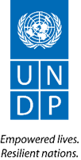
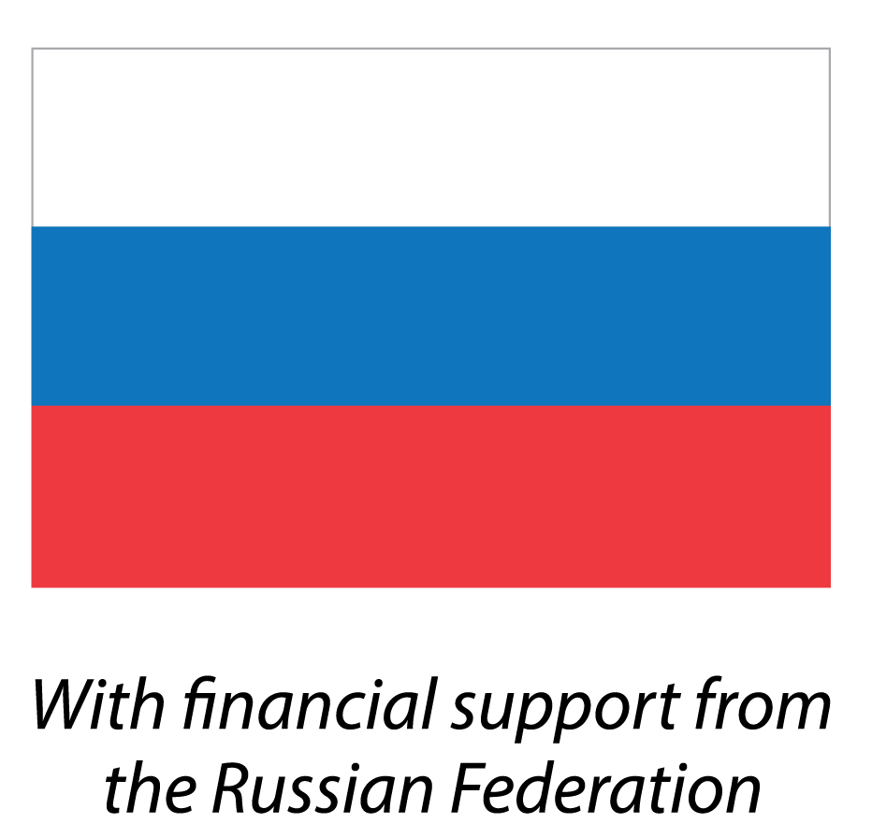

With the financial support of the Russian Federation

Training Module for Teachers
‘’Introduction to the Climate Change Issues and the Practical Application of the ‘Climate Box’ Interactive Learning
Toolkit in Educational Organizations’’

Methodological Recommendations on the Organization of Network and Interagency Collaboration, the Society Involvement in the Implementation and Promotion of Creative and Social Activities Aimed at Reducing the Impact on the Climate and Adaptation to Climate Change



September 2020
Significance of Networking and Interagency Collaboration for Climate Education
The current climate change is recognized by the United Nations (UN) as one of the most important global problems of humanity. The climate change effects are being felt in all countries and regions of the world, and each person is responsible to one degree or another for the changes taking place on the planet.
Education is a critical element in the global response to climate change. It helps young people understand and remediate the effects of global warming, fosters change in their attitudes and behavior, and helps them adapt to climate change trends.
Networking and interagency collaboration allows to consolidate all available resources of both ministries, public and private companies, and individuals – experts, volunteers, eco-leaders – to promote awareness of the population and especially young people on climate change issues. This interaction is an effective tool for expanding opportunities for climate education and awareness at all levels.
Networking is established between educational organizations and provides participants with the ability to use shared resources. Not all educational organizations have the same opportunities in terms of methodical resources, personnel, materials. Network partnerships provide all students with the same opportunities to gain knowledge on many issues, including climate change.
Interagency collaboration is established between organizations of different departmental and structural affiliation to solve common problems. As climate change is one of the main challenges today and already threatens the lives, health and livelihoods of hundreds of millions of people, numerous organizations are interested in activities to raise public awareness of climate change issues and promote climate-friendly lifestyles. Such cooperation allows educational organizations to attract scientific, environmental organizations, cultural institutions, and industrial enterprises using low-carbon technologies, non-state funds and programmes to solve problems in the field of climate education.
Such cooperation is important first of all, for building the career management system that made it possible for teachers to professionally master the climate change issues.
Consolidation of networking and interagency resources promotes quality assurance in climate education, raising youth awareness of climate change, and expanding non-formal education programmes through media, networks and partnerships.
In 2014-2015, the United Nations Development Programme (UNDP) developed and tested in Russia a new innovative interactive educational toolkit on climate change – the Climate Box, designed to attract the attention of schoolchildren and introduce them to the science behind climate change, inform them how climate change affects people and ecosystems, and how each person can contribute to the global effort to combat climate change. From 2016 to 2020, UNDP, with financial support from the Russian Federation, supported the replication of the Climate Box project in Eastern Europe and Central Asia – Armenia, Belarus, Kazakhstan, Kyrgyzstan, Moldova, Tajikistan, Turkmenistan and Uzbekistan. Serbia also joined the project in 2020, becoming the first country outside the CIS region participating in the project.
Each country, using the basic material of the UNDP Climate Box interactive learning toolkit, made additions reflecting the specific climatic and natural conditions of their country and the typical problems associated with climate change, adaptation measures and examples of the most successful solutions to reduce carbon dioxide emissions. All this made the toolkit more visual for schoolchildren in each specific country.
This approach required the involvement of experts from various fields: climatologists, geographers, biologists, economists, educational specialists, even professional children's writers. Experienced teachers made a great contribution to the project, who helped to develop educational recommendations for teachers on the use of the Climate Box toolkit in school classes. This cross-sectoral approach to the toolkit development has made it a truly interdisciplinary and comprehensive textbook on climate education for schoolchildren.
Examples of Networking and Interagency Cooperation for Climate Education in the Countries of the Climate Box Project
Thanks to the Climate Box project implementation, the specialists who can share their experience have been retrained in the countries, and the Climate Box itself can be used not only in school education, but also in the implementation of non-formal education programmes by various non-governmental organizations (NGOs), international organizations and foundations.
A good example is the cooperation between the Climate Box project with a number of organizations in Armenia, Belarus and Kazakhstan.
Armenia
- In cooperation with the National Center for Educational Technologies, 24 secondary school teachers were retrained on climate change and the use of the Climate Box kit in schools. The training took place remotely.
- Specialists trained under the Climate Box project in cooperation with the Swiss humanitarian foundation "Kaza" have retrained 30 secondary school teachers on sustainable development and climate change. In the process of retraining, the materials of the Climate Box toolkit were used.
Creating an educational space to raise awareness of climate change, build sustainable lifestyles is effective when using an interdisciplinary approach and attracting as many participants as possible from various fields. Non-profit associations, local organizations and institutions, experts and volunteers from various fields participating in educational seminars, research competitions, talent nights, public sessions, round-tables and other events will be able to provide additional support in moderating events or implementing and promoting creative and social activities which they are designed for.
Thus, in Armenia, with the support of the ATP (ARMENIA TREE PROJECT) charitable foundation, it became possible to implement EcoSad, the schoolchildren’s project, which took part in the national stage of the I International School Projects Competition "Climate Box". This project on landscaping and landscaping with using recycled materials (plastic, tires, wooden pallets, etc.) was carried out in one of the schools in Yerevan.
At the events of the United Nations Children's Fund (UNICEF) in Armenia, projects developed by schoolchildren on resource conservation and reduction of carbon dioxide emissions “Less food in the bin”, “Ecosad”, mobile application “Water is life” were presented. This contributed to the popularization of the Climate Box toolkit and the educational initiatives developed with its use.
Thanks to the collaboration between the Climate Box project and other UNDP projects on climate change awareness in Armenia additional materials have been developed, which are included in the Climate Box toolkit:
- supplementing the Climate Box international version with materials on energy efficiency and developing a separate brochure “Energy Efficiency” with the support of the project “Legal and regulatory framework for promoting energy efficiency in the countries of the Eurasian Economic Union (EAEU);
- designing a poster "Adaptation to Climate Change" with the support of the project "National Adaptation Plan in Armenia".
Kazakhstan
In Kazakhstan, the Fund for the Development of Socially Significant Initiatives has become a key partner on climate education, the development of a Climate Box national version and its introduction into the educational process. The Fund supports the implementation of systemic environmental initiatives aimed at protecting the environment, improving the quality of life of citizens, promoting the principles of a green lifestyle and other socially useful goals in Kazakhstan.
Climate Box, as one of the projects supported by the Fund, was well represented to the participants and guests of the "Together Brighter" (“Vmeste Yarche”) festival in Kazakhstan, organized by the UNDP initiative, held in twelve regions of Kazakhstan with the active support of the education departments of these regions. This made it possible to draw attention to Climate Box as a basic material for schoolchildren for studying climate change issues and inform large sectors of the population and many organizations which can influence its promotion with the possibilities of its content. Such support helps to attract financial resources to climate education both for educational activities and for the land and school buildings’ improvement according to the principles of "green building", the installation of energy-saving equipment, meteorological sites, visual models for studying the climate.
The use of the materials is much wider than curricula in school disciplines: it can also be actively used in the organization of extracurricular activities and in the development of further education programmes, non-formal education of students.
Through the holding of thematic weeks, environmental actions, competitions and quizzes in educational institutions, the involvement of society in this activity is enhanced: children actively participate in competitions and thematic events, active social activities – thanks to participation in campaigns and projects to reduce the impact on the climate. Such climate-friendly behavior, creative and social activities of schoolchildren have an impact on their parents, friends, on the educational institution staff.
Outreach activities also actively involve the local community in a climate-responsible lifestyle. The study of the interrelationships of the components of natural complexes, the impact of climate and its changes on humans, their economic activity, everyday life and health, getting an idea of ​​the anthropogenic impact on the climate and ways to minimize it form the values ​​of responsible consumption and attitude to nature, rules for the economical use of resources and energy conservation, which makes a significant contribution to preventing climate change.
Belarus
In Belarus, the Climate Box introduction into the educational process is carried out through the network of Green Schools, which are the state educational resource for environmental education and the children involvement in practical activities for nature conservation. The Green Schools project is coordinated by the Ministry of Education of Belarus in cooperation with the Ministry of Natural Resources and Environmental Protection and is implemented as part of the Eco-Monitoring project with the support of UNDP and funding from the European Union.
The Climate Box incorporation into the educational and nurturing process through the Green Schools enabled to use the resources of this network to create an effective education model on climate change issues. Interaction is ensured by the general organizational and methodological support, which is carried out by 7 resource centers covering various regions of Belarus. To organize practical work, 18 pilot sites were created with special equipment, which is used for research work both in various environmental areas and on climate change. All schools in the region where these sites are created can use this resource.
Information activities is an important aspect of the Green Schools and includes, inter alia, the following activities:
- preparation and placing visual information materials created by students for the local population in public places, related to climate change, its consequences, ways to adapt and reduce the impact on climate;
- preparation, organization and holding of information events for the local population (festivals, performances in front of the public, etc.);
- carrying out ecological activities (collecting waste paper, planting trees, reusing, etc.) with the local population involved and their coverage in the media;
- development and promotion of initiatives to reduce the impact on the climate for the administration of a local settlement, district: installation of energy-saving equipment in educational organizations, equipping school grounds with drip irrigation systems and others.
Cooperation with non-profit organizations, educational institutions, experts and volunteers from various fields when holding events using the Climate Box is invaluable: it makes it possible to pay attention to the processes taking place in this particular area, which significantly increases susceptibility to the received information and make it less abstract.
In addition, partners will share messages in the media and social networks and post content related to the ongoing joint activities. This will create a large information field for the promotion of the Climate Box toolkit and climate education in general.

